Functional, Technical, Implementation Specification for ENHANCEMENTS Template

Defect 3028 – Technical Object as Mandatory field for Create/Change Notification and Maintenance Order Apps

Date: 13 April 2020
Version: 1.0

Contents
1 Document semantics 4
1.1 Document Properties 4
1.2 Amendment History 4
1.3 Distribution 4
1.4 Approval 4
2 QA’s & SIGNOFFS 5
3 Introduction 6
4 Functional Specification Overview 7
4.1 General Information 7
4.1.1 Business Owners and Key Users 7
4.1.2 Model / Process 7
4.1.3 Enhancement Description 7
4.1.4 Business Units Impacted 7
4.1.5 Dependencies 7
4.1.6 Legal requirements (if any) 7
4.1.7 Process Standardization 7
4.1.8 Starting Conditions 8
4.1.9 Frequency 8
4.1.10 Volume of Data 8
4.1.12 Business Controls 8
4.1.13 Security 8
4.1.14 Error Handling - Recovery and Restart 8
4.1.15 Assumptions / Exclusions 9
5 Functional Solution – Enhancement Overview 10
5.1 Type of Enhancement 10
5.2 Program Flow 10
5.3 Impact of Change on the System 10
5.4 Prototyping 10
6 Testing Requirements 11
6.1 Test Scenarios to confirm the Change 11
6.2 Regression Test Scenarios 11
7 Issues 12
7.1 Technical Issues And Resolutions 12
8 Change Requests 13
8.1 Change Requests 13
9 Technical Specification 14
9.1 Technical Flow Diagram 14
9.2 Program Flow Logic (Pseudo Code) 14
9.3 Technical Workshop Output (If Any) 14
10 Implementation Section (PD) 3.1 Deploy 15
10.1 User Instructions: 15
10.1.1 Procedures For Processing 15
10.1.2 Frequency 15
10.1.3 Manual Processing 15
10.1.4 Error Handling 15
10.1.5 Clearing Out Directories and BDCs 15
10.1.6 Problem Reporting 15
10.1.7 SAP Programs and Related Documents 15
10.1.8 Business Controls and Security 15
10.2 SAP Job Definitions 15
10.3 Scheduling/Filewatch Jobs 15
10.4 SAP Job & Filewatch Flow diagram 16
10.5 System Outage Recovery 16
10.6 Messages 16
10.7 Control Tables 16
10.8 File Disposition 16
10.9 Job Intervention 16
10.10 Issues 16
10.11 Cross-reference documents 16
Appendices 17
Appendix A : Error Handling 17
Appendix B : Testing Plan 18
B.1 Master Test Lists 18
B.2 Change Request Number XYZ 18
B.3 Tests to confirm the change 18
B.4 Regression Tests 18
B.5 Impacted ITC scripts 18
Appendix C : Custom Table 19
Appendix D : Selection Criteria 20
Appendix E : List of Objects 21

Document semantics

Document Properties
Owner and contact information
Document Prepared by: | Pranay Dubey
Standards Owner:
Contact Information:
Responsible Team: | GAME

Amendment History
Amendment history for document
Revision No | Revision Date | Author(s) | Comments/Major Changes
1.00 | 13/04/2020 | Pranay Dubey | Initial Draft

Summary of Changes since last revision
Section / Topic | Short Description of the Change

Distribution
List recipients for distribution of document
Group | Recipient | Role | Level of Involvement

Approval
List of persons required for approval of document
Name | Title | Date | Signature
Kumar Loganathan | GAME Design Lead

QA’s & SIGNOFFS
 | 2.3 Design |  | 3.1 Tech Design |  | 3.1 Program Unit Test |  | 3.3 Deploy
QA Date: |  | QA Date: |  | QA Date: |  | QA Date:
Author | Pranay Dubey | Author |  | Developer |  | Author
Business Owner |  | Business Owner |  | Basis/DBA |  | Business Owner
Analyst |  | Analyst |  | Analyst | Pranay Dubey | Analyst
 |  | Developer | Suganth Thiyagarajan | Business Owner |  | Developer
Security |  | Security |  |  |  | Security
Basis/DBA |  | Basis/DBA |  |  |  | Basis/DBA
Support |  | Support |  |  |  | Support

Introduction

In plant maintenance, notification data is used to keep track of equipment maintenance history like object, damage and cause codes. SAP standard WebDynpro apps does not require users to input data in the technical object field as mandatory and users have tendency to forget filling this out; therefore, notifications and work orders are usually created with incomplete information. This enhancement will be in place to ensure that the technical object field is always filled out when notification or work order is created.

Functional Specification Overview
Enhancement Number and Name: Technical Object as Mandatory field for Create/Change Notification and Maintenance Order Apps

Written By: Date Completed: 07/08/2019
Pranay Dubey

Functional Contact : (Required) Phone#:(Required) 7722046469
Name the primary functional contact for this enhancement

Pranay Dubey
Technical Contact : Phone#:
Name the primary technical contact for this enhancement

Suganth Thiyagarajan
Connected Portfolio Contact: Phone#:
Name the primary Connected Portfolio contact for this enhancement

DHD Reference:
Identify the relevant DHD, Legal and Fiscal Requirements or Change Request

General Information

Business Owners and Key Users
Who are the business owners of this process? (Companies, organizations, names, phone numbers)

Model / Process
Please describe how the enhancement fits into the overall business process. Use bullet points, flowcharts and/or pictures to illustrate the process.

When the maintenance notification/order is created , the Foreman or Craftsman or Contractor must record technical object as mandatory.

The enhancement is implemented to ensure that notifications / orders are created with technical object as mandatory from Webdynpro Apps.

Enhancement Description
Write a descriptive overview paragraph about the gap, the enhancement and the underlying business case for the enhancement. Why is this enhancement important to the business? What is the impact if the enhancement is not coded? What are the business dependencies (i.e. billing must complete, inventory must be updated first).
Enough detail should be provided so that someone with knowledge of SAP R/3 and knowledge of the business processes can understand the solution. If there are alternative solutions in SAP R/3 that have been ruled out mention them here.

Are there any known similar enhancements, which could be used to help in the development of this enhancement?

In plant maintenance notification data is used to keep track of equipment maintenance history like object, damage and cause codes. SAP standard Wendynpro apps does not require users to input data in the Technical Objects and users have tendency to forget filling them out; therefore, notifications are usually closed with incomplete information. This enhancement is proposed to assure that technical object field is filled out when notification / order is created. The enhancement will include implementation of the Feeder Class /PLMU/CL_FRW_G_FEEDER_FORM and method GET_DATA will be used to make technical object as mandatory for WebDynpro apps.

Technical history recorded at the equipment level will be input to Reliability studies to identify possible failure modes coming from real life experiences. One of the main objectives in the GAME design is to improve the plants reliability by using the Risk Reliability Methods resulting in new preventive maintenance plans. Without proper input from the notifications the Reliability study might exclude failure modes, which have occurred in real life. As a consequence, the result of the study may not be correct leading to incomplete preventive maintenance tasks. Notification history is not available for ‘bad actors’ analysis.

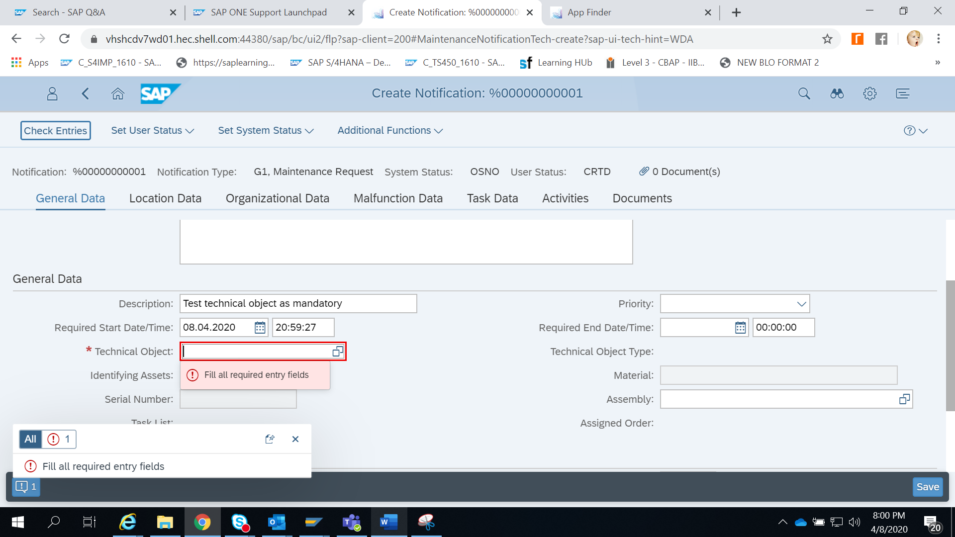

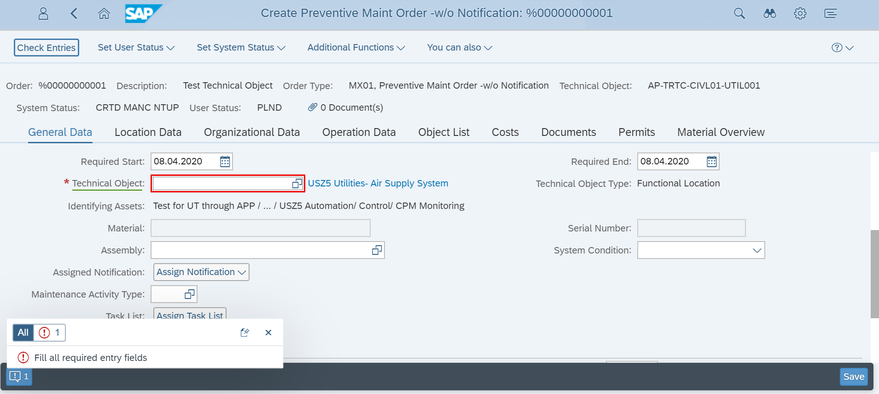

Business Units Impacted
What are all the business areas affected by this enhancement.

Luminon / Manufacture / Maintenance / Pipeline / T&S

Dependencies
Specify any dependencies on other Functional Specifications.
None

Legal requirements (if any)

Process Standardization
Degree of Standardisation | Corporate  Common  Individual

▼ Describe each deviation from Corporate Standard. Justify each deviation / exception in terms of Fiscal, Legal, Physical, or Customer constraints / requirements that have caused the variance, excluding items pertaining to the form appearance, such as viewing language, and including items, such as additional fields, rearrangement of form content, or different logo / graphics.

Deviation from Corporate Standards | Justification for Deviation

How is the data in the report classified (Unrestricted, Restricted, Confidential, Most Confidential)?

Starting Conditions
Include when/how the enhancement will be triggered? Is there a specific event that will trigger the enhancement functionality?

The enhancement will be triggered when users’ create notifications and work orders from WebDynpro Apps

Frequency
Detail how often the enhancement will run?
The enhancement is triggered when users try to create notifications or work orders, and it is likely to occur about 50-60 times daily (rough estimate).

E.g. ‘This enhancement will be run each time a billing document is displayed, and this is likely to occur an estimated 10 times daily’.

Volume of Data
Detail the expected volume of data.
No mass data is involved in the enhancement execution. A single notification or work order is processed when enhancement is triggered and executed.

Business Controls
Business Controls
Outline all required business controls for this development in relation to the business process. Should error logs be created and sent to the business controllers? State if controls are not required and ensure this has business support

No control report is required for this enhancement. Users will be required to input missing data (technical object) before they can proceed further with creating notification or work order.

Report Controls
Review the Controls Register for controls relevant to configuration of this report. If the Controls Register requires additional controls consideration, which affects the report being configured in this document, please document the additional detailed configurable control requirements in this section.
E.g. If this document is the basis for configuring a Vendor Master List Display Report to show all changes to vendor masters, the Controls Register may require the report to specifically display changes to vendor master bank accounts ONLY (separate from other changes). Such requirements will need to be documented in this location.

NA

Data Classification and Quality Controls
A Baseline level of security is defined and implemented across the Shell Group. Compliance to it is mandatory. A formal risk assessment must be conducted using the IT4S Information Security Classification Standard to establish information classification level and IdM Assurance Level requirements.
How is the data in the report classified (Unrestricted, Restricted, Confidential, Most Confidential)? What data quality requirements and controls are required? This is usually done via a risk assessment process. Data quality has many dimensions – not just accuracy. What are for each piece of critical data the specific dimensions of data quality that may cause process failure? What are the quality levels for those dimensions, which will achieve the required quality level? What are the possible controls for those dimensions, which will achieve the required quality level? Does confidentiality need to be ensured? Does Integrity need to be kept? Does availability need to be kept? Does authentication need to be ensured? Does action to or processing needs to be recorded?
If data quality controls are not required, the specs should state the reasons why it was not required.

NA
Compliance
Does the report need to meet any specific contractual, legal and regulatory compliance requirements? Does the data transfer cross country borders? E.g. export compliance, crypto controls, SOX compliance.
To meet the Shell security-requirements all own-developments should include authorization checks e.g. around display critical data. The actual authorization checks (object, values) to be used can be defined here. If it is not, then it must be defined in the technical specification.
Who in the business should have the authority to run this report cluster (i.e. restriction by named individual)?

NA
User Categories
Which Roles need or are only allowed access? Should or can external or third party users have access?

NA

Security

Business Role Name:
Which Business Roles should get access to the new transactions ( e.g FSS237 )?

Transaction: IW21/22/31/32/41/42
Provide Technical name of new transaction if already known.

Transaction Type:
Outline the type of the transaction (e.g. Display, Update, Table maintenance, upload, download). If it is a table maintenance transaction also outline the table name.

Restrictions / Authorization Checks:
To meet the Shell security-requirements all own-developments should include authorization checks e.g. around display critical data.
How will the transaction be secured? Which authorization object will be used or on which organizational level will be restricted (e.g. plant, country code)? Is the transaction MOA relevant and need special restrictions therefore?

As this enhancement only do plausibility checks and all necessary authorizations checks are already included in transactions IW21, IW22 and IW32 no further authorizaiton checks are required. (This enhancement is put in place to ensure that the technical object field is always filled out when notification/order is created.)
Data Classification (unrestricted/restricted/confidential):In this section include any other information that is helpful to the design of the program, e.g.
- All weights in the SAP system will be in kilograms
- Deliveries will have a maximum of 5 line items
Also, include any exclusions, e.g.
- Deleted orders will be excluded from the selection.
- Exclude company code YZ01

Error Handling - Recovery and Restart
Describe instances where errors may occur.
If the enhancement fails at any stage will this have an impact on any actions to be taken after its completion?
Should it be possible for the enhancement to ‘fail’?
Should the enhancement alter the user if data which should be present, is missing? How should this be communicated?
Consider using the table in Appendix A: Error Handling to highlight potential errors and what has to be done.

Assumptions / Exclusions

The enhancement should check all notifications and order types

Functional Solution – Enhancement Overview

Type of Enhancement
Provide details of the type of enhancement required (customer exit, implementation of an OSS note to amend standard SAP, new program / utility etc.), including component names and types (e.g. function modules, transactions).
Include here the name of the original program that is being enhanced or the name of the program name on which the new program can be based on.

Feeder Class /PLMU/CL_FRW_G_FEEDER_FORM and method GET_DATA will be used to make technical object as mandatory for the WebDynpro apps.

Program Flow
Outline the design details or change details as required. As much information as possible should be provided here to ease the transition to technical specification.
E.g. ‘1) Select all customers with account group
‘2) Read all the bank numbers where

Custom code needs to be inserted in the following feeder class via post exit in the method:

Feeder Class /PLMU/CL_FRW_G_FEEDER_FORM
Method GET_DATA

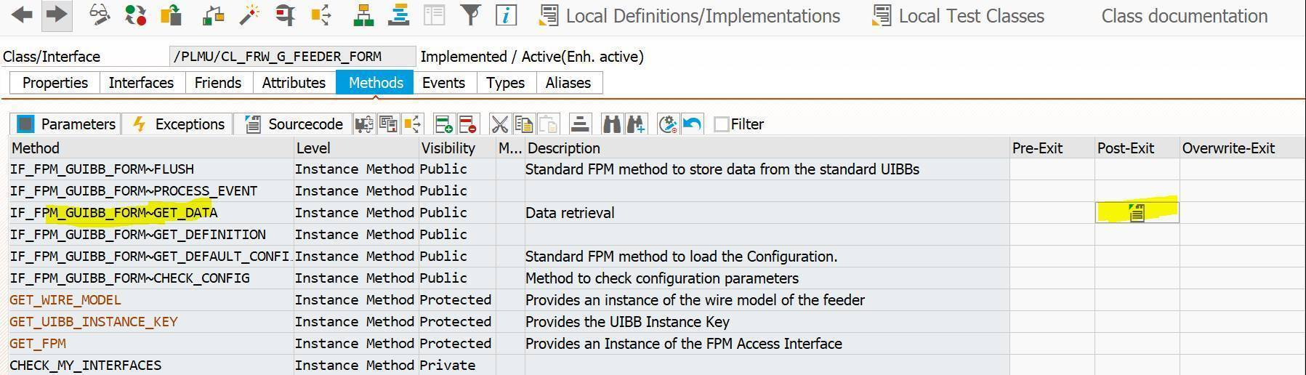

Impact of Change on the System

No negative impact is anticipated to other areas of the system. Since logic in the post exit uses key field when searching table/structure, performance should not be a problem either.

No negative impact is anticipated to other modules in the system. Key field is used in the logic to search for matched record, no negative impact to system performance should occur.
The main problem with user exits is that they can often have unforeseen impact on other areas of the system. This means that not only does the solution have to be thoroughly investigated and tailored to the exact nature of the problem but also that the impact of this change on the rest of the system should be detailed and thoroughly checked. Areas that are likely to be impacted should be identified and the possible outcome noted so that during testing they can be focused upon.

Prototyping
Has the Enhancement been prototyped? (please mark as appropriate) | Yes | No
 |  | 

If the enhancement has been prototyped, please provide the link to the relevant prototype documentation and sign-off documents.

The purpose of this paragraph is to provide any additional background that would help clarifying the solution to the Technical Analyst or whoever is reading the document.
It is important to note that the prototype is done and agreed at the early stages of the development cycle, so it will not include all the details of the final solution. It is also important to note that – in several cases – the final solution is different from the one prototyped due to evolving requirements, better understanding of the requirements or technical issues encountered during the detailed design: this paragraph will therefore contain the links to the original view on the solution.

Testing Requirements
The purpose of this section is to provide context to the detailed test conditions which are identified in Appendix B. The intent is to assist the reader by providing an overall picture of the testing requirements in a summary form in order to allow an initial assessment of the completeness of the unit tests that is listed in Appendix B

Test Scenarios to confirm the Change
Use this section to identify high level test conditions and mention CAP/Process steps/scenarios that will be directly impacted by this change. Describe test scenarios where applicable. It is expected that there will be a one to many (1:N) relationship between the test scenarios described here with the Unit Tests identified in Appendix B.

Example:
In Section 6:
- Enhancement is triggered upon load confirmation to update new custom table with relevant delivery information

In Appendix B:
- Unit Test 1: Enhancement is triggered upon load confirmation to update new custom table with one delivery item. Expected result: Custom table will have a new line created with relevant delivery information.
- Unit Test 2: Enhancement is triggered upon load confirmation to update new custom table with two delivery item. Expected result: Custom table will have two new lines created with relevant delivery information.

Regression Test Scenarios
This section is relevant especially when introducing a change that has a direct impact on a critical path of a process. For example, when we make a change during Sales Order save or Delivery save, although the functional change should only be triggered based on a specific set of conditions (i.e. depending on order type for instance), we will need to ensure that the standard process still works properly for all other order types. Put N/A if no regression testing is required.

Issues
This section highlights areas that always cause design problems. It is included to force the designer to consider these issues. The designer should consider the examples and add additional details where appropriate.

E.g.

- Language of texts - The texts in the enhancement may be different in different countries. What language should be used to derive these texts? The login language or another?
- Volume of data - Will the enhancement be executed often? If this is the case will it impact the system adversely? Is there a better solution that will not affect the performance of the system?
- Currency and Units of Measure - Will the enhancement work for different currencies? What happens if the common measure of weight used on the client’s sites is changed to tonnes instead of kilograms? If any fields used in the enhancement are measured in units, the designer must consider how this will affect the functionality

Technical Issues And Resolutions

Developer will document the technical issues and resolutions here

Change Requests
The purpose of this section is to serve as a repository of Changes Requests which impacted this RIEF and provide an overview of the deltas throughout the lifecycle of the functionality and the history behind the evolution of the said RIEF.

Change Requests

Provide CR number and description here. Please insert when adding new CR and repeat the below headings for each CR.

Background
Give an explanation of the functional change requested and impacted business scenario including line of business where applicable. Most background information should already be identified in the Change Requests database in PM Toolkit. Please extend the descriptions where possible using diagrams to represent business process flow impacted if applicable. Please refer to Streamline Level 5 swim lanes where available

Delta

Functional Solution
Provide the detailed functional solution in this sub section. Use of diagrams to represent the data/process flow is strongly encouraged to provide additional clarity to target readers of the RIEF

Technical Specification

This section should outline in more detail the technical solution. This will be completed by the technical analyst and should contain information such as pseudo code, detailed database selects, complex calculations and conversions, critical decision logic etc. It should also outline performance considerations. Any additional authorisation checks need to be included here. The technical analyst should request assistance from the functional analyst as required. This section should help to ensure that the technical analyst has understood the functional design, and can convey the development requirements to the developers.
If additional technical documentation is available but not included in this document then cross-reference here.

Technical Flow Diagram
Include the systems and their inter-relationships

SAP Enhancement :

Program Flow Logic (Pseudo Code)

For complex functionality consider providing pseudo code to aid in the final coding, bear in mind the IHUB technology selected.

Technical Workshop Output (If Any)
This section should outline high level technical design as out put of the workshop. Offshore technical analyst will complete this section during workshop period at onsite.

Implementation Section (PD) 3.1 Deploy

User Instructions:

Procedures For Processing
List the processes in carrying out the task including program names, inputs and file names

Frequency
How often is the procedure carried out and times of filewatch

Manual Processing
How is the process performed manually if the program does not work

Error Handling
How are the errors identified, and what needs to be done to correct them, such as BDC names

Clearing Out Directories and BDCs
Frequency and process for maintaining files & jobs by clearing out directories & BDCs

Problem Reporting
List who should be contacted or to which area in support that a service center ticket needs to be generated.

SAP Programs and Related Documents
List any other programs and their documents affiliated with this application.

Business Controls and Security
Please list the names of any roles, authorizations (authorization objects, values) or profiles that are being used to perform the authorization checks.

SAP Job Definitions
Job Name:________________________

Step # | Program Name | Variant Used | Print Requirements | Submitted Jobs | SAP Updated  (yes,no)
 |  | Name (Is any maintenance required of variant) | Printer Name, User, Title, who will receive the report | List any BDC, RFBIBL00, or other jobs submitted by this step. | Is this step restartable, does it update SAP?

Scheduling/Filewatch Jobs
Application | Group Name | Job Name | Job Description | SAP Job Name | Dependency | Job Filename | Documentation File name
Customer | C0201 | FW_CUSXX | Search for .end file
Customer | 0201 | DL_CUSXX | Delete the .end file |  | FW_CUSXX
Customer | C0201 | CUSTXXC | Run batch input of files | ZDLY0204_CUST_LOGICRAFT_CUST0023 | DL_CUSXX

SAP Job & Filewatch Flow diagram
Provide a flow chart showing all the SAP jobs, steps and control M-jobs being performed.

System Outage Recovery
In the event SAP is unavailable due to a system outage what will be required to run the process when SAP becomes available. Consider processing multiple files, ignoring the run, etc.

Messages
List all error messages produced. The following is just an example, use a format that is appropriate for your application. For tables use WinWord STYLE "Table" so that columns will not be indented. Reference programming standards document.

JOB STEP | CODE | MESSAGE | WHAT ACTION SHOULD BE TAKEN
1 | R1A | Invoice number is missing | No action
1 | R1B | Invoice number in distribution file is missing | No action
1 | R1C | Invoice number in manual check file is missing | No action
1 | R2A | Invoice amount is missing | No action
2 | R3A | File reject due to duplicate processing | Correct file and rerun

Control Tables
Are there any custom (Z) tables used to control the processing of this job? (ZINT, ZJOB, etc). Do they require updating in the event of a job failure?

File Disposition
What steps are being done to remove used files and no-longer-needed archive files from production directories.

Job Intervention
List any situation that would require intervention by scheduling or production support.

Issues
Note any design points or questions which remain open.

Cross-reference documents
Attach any relevant documents.

Appendices
The appendix should cover any essential information not covered in the sections above, such as the required structure of a custom table.

Error Handling
Consider the test steps and data required to test this development. The functional and technical analyst should complete this section.

N^{o.} | Potential Errors | Resolution | Notification Procedures
1 | Look-up tables not maintained | Error message and termination of program | Report error to be created and sent to inbox of business contact.
2
3

Testing Plan

B.1 Master Test Lists
The Master Test Lists section contains all valid test conditions for the RIEF. Every time when a subsequent CR is raised this section needs to be reviewed as well to make sure that the listed test conditions are still valid and not superseded by the latest change.
In case of a brand new RIEF this section will be blank and all testing requirements will be documented in the below paragraphs under the CR number.
Once a subsequent CR is raised testing requirements documented under “TESTS TO CONFORM THE CHANGE” usually will be cut&pasted into this paragraph. Please note that some of the original test requirements might not be valid any more due to the latest change we are about to implement (original functionality is modified by the latest CR therefore testing requirement is not valid any more). Those needs to removed from the Master Test List

N^{o.} | HPQC Unit Test Scenario | Roles | Test Conditions | Test Data Description | Expected Results
1 | Here we need to reference either to an existing or to a new HPQC Unit test scenario. In case of a new scenario we should decide how to call this scenario, which can be used later on during HPQC scripting. | List the Roles involved to test this test condition (could be more than one role) | Define the test condition you will cover here | Provide a description what special type of data (customer/product/etc...) we need to test this condition | Please describe the expected result for this test condition with the data provided in the previous column
2
3

B.2 Change Request Number XYZ
The CR number needs to be reflected in the paragraph header above. In case we combine multiple CRs to be implemented at the same time than all CR numbers need to be listed

This paragraph will contain the test requirements related to the above listed CRs. We have two sub-paragraphs to cover required test activities to confirm that the changes what we are about to implement:
- are working as expected (Tests to confirm the change)
- do not have negative impact on existing RIEF functionality implemented before (Regression tests)

The CR number(s) in the paragraph header always needs to be updated every time a new CR is raised (this paragraph always describe the testing requirements for the latest implemented CR(s))

B.3 Tests to confirm the change
Here we need to list the required tests to confirm that the changes we are about to implement (related to the CRs mentioned in the paragraph header above) are working as expected (can be a mixture of both positive and negative test conditions).

Once a subsequent CR is raised against this RIEF the testing requirements documented here usually will be cut&pasted into the “Master Test Lists” paragraph. Therefore with a new CR you would DELETE the contents of this (and the Regression test) section relating to the previous CR and create this paragraph from scratch for the change related to this new CR
Please note that there might be cases when the new CR will supersede some of these test requirements therefore filtering needs to be done before the cut&paste.

N^{o.} | HPQC Unit Test Scenario | Roles | Test Conditions | Test Data Description | Input data for SB testing | Expected Results
1 | Here we need to reference either to an existing or to a new HPQC Unit test scenario. In case of a new scenario we should decide how to call this scenario, which can be used later on during HPQC scripting. | List the Roles involved to test this test condition (could be more than one role) | Define the test condition you will cover here | Provide a description what special type of data (customer/product/etc...) we need to test this condition | Provide existing data codes (e.g. product number, PO number, etc...) in DEV system for SB to perform their testing before handing back the RIEF for unit testing to the process team | Please describe the expected result for this test condition with the data provided in the previous column
2
3

B.4 Regression Tests
Here we need to list the required tests to confirm that the changes we are about to implement (related to the CRs mentioned in the paragraph header above) do not have negative impact on existing RIEF functionality implemented before.
Based on the nature of the change we are about the implement we need to select a subset of the test requirements documented under the “Master Test Lists” paragraph.

Once a subsequent CR is raised against this RIEF the testing requirements - relating to the previous CR - documented here get deleted and we will start from scratch for the new CR.

N^{o.} | HPQC Unit Test Scenario | Roles | Test Conditions | Test Data Description | Input data for SB testing | Expected Results
1 | Here we need to reference either to an existing or to a new HPQC Unit test scenario. In case of a new scenario we should decide how to call this scenario, which can be used later on during HPQC scripting. | List the Roles involved to test this test condition (could be more than one role) | Define the test condition you will cover here | Provide a description what special type of data (customer/product/etc...) we need to test this condition | Provide existing data codes (e.g. product number, PO number, etc...) in DEV system for SB to perform their testing before handing back the RIEF for unit testing to the process team | Please describe the expected result for this test condition with the data provided in the previous column
2
3

B.5 Impacted ITC scripts
Here we need to list all the impacted ITC scripts that needs to be created or adjusted in order to cover this new/modified RIEF.

HPQC ST or ITC Test Scenario | Create or Change | Comments
Here we need to reference either to an existing or to a new HPQC Test or ITC scenario. In case of a new scenario we should decide how to call this scenario, which can be used later on during HPQC scripting. | Specify if you expect a new scenario to be created or an existing one to be changed | Any other comments further specifying the scenario impact

Custom Table
Briefly explain any custom tables involved in this enhancement and reference any associated documentation.

Selection Criteria
Designers should be able to detail exactly what criteria they want to use to selectively extract data from the database. The developer will be able to construct the selection-screen directly from the details in this following table:

Criteria | Data Type | Value | Mandatory field? | Selection-screen Type | Comments
Service Master number | ASMD-ASNUM | From 1000000000  To 1999999999 | Yes | R
Language | ASMDT-SPRAS | EN | No | SV

Legend
Criteria | Description to be used on the screen.  Example: ‘Company Code’.
Data Type | The SAP field, the field should be based on or length and data type.  Example 1: T001-BUKRS; Example 2: CHAR(004).
Value | Value of selection criterions.  Example: Parameter ID ‘BUK’
Mandatory Field | Does the field have to be populated before processing?
Selection-screen Type | The choices here would be:  SV – Single value (equivalent to a PARAMETER) ;  SR – Single range (SELECT-OPTIONS NO EXTENSION) ;  MV – Multiple values (SELECT-OPTIONS NO INTERVALS) ;  R – Range (a normal SELECT-OPTIONS) ;  CB – Check-box;  RB – Radio-button.
Comments | Any specific functionality that needs to be described can be added here or referenced into the notes below.  Example: Only valid company codes should be entered.

List of Objects

Object Type | Object name

